Model Training & Optimization

How does a neural network transform from random guesser to intelligent predictor? Through training which is the process where networks learn from mistakes and gradually adjust millions of parameters. In this lesson, you'll discover how networks learn through backpropagation, how optimizers accelerate this process, and how to prevent models from memorizing instead of understanding.
1. The Learning Mechanism
1.1 Forward Propagation: Making Predictions
Neural networks consist of neurons, layers, and activation functions. But how does a network actually make a prediction? Through forward propagation—the data's journey through the network.
The process:
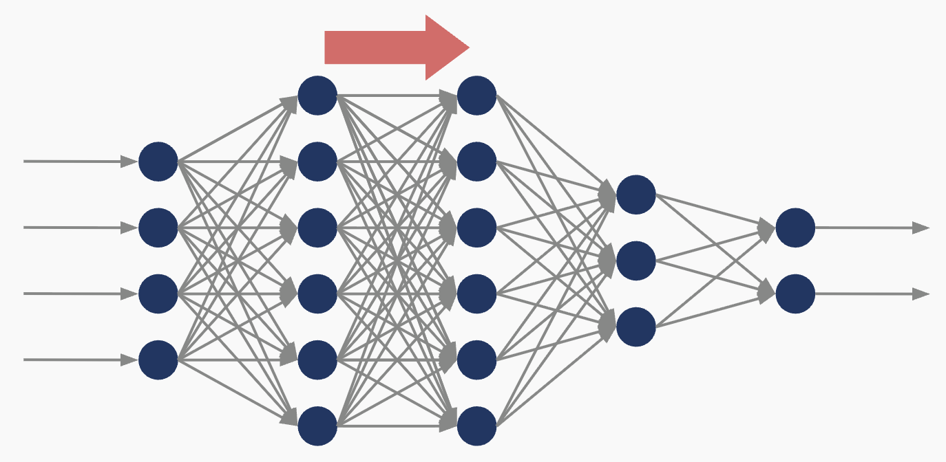
Figure - Forward Propagation
- Input layer receives raw data (pixel values, text features, sensor readings)
- First hidden layer processes inputs: each neuron computes weighted sum → applies activation function
- Output flows forward to the next layer, repeating the process
- Continue layer by layer until reaching the output layer
- Final output is your prediction
Think of an assembly line: raw materials enter, each station transforms them, and a finished product emerges.
Note: If your network is untrained, predictions are random. Weights start as random numbers, so the network makes wild guesses. This is normal! Intelligence emerges through training, which consists of learning to adjust these weights based on mistakes.
1.2 Learning From Mistakes: Backpropagation
Forward propagation generates predictions. But how does the network improve? Through backpropagation, which is the mechanism that enables learning from errors.
The three-step process:
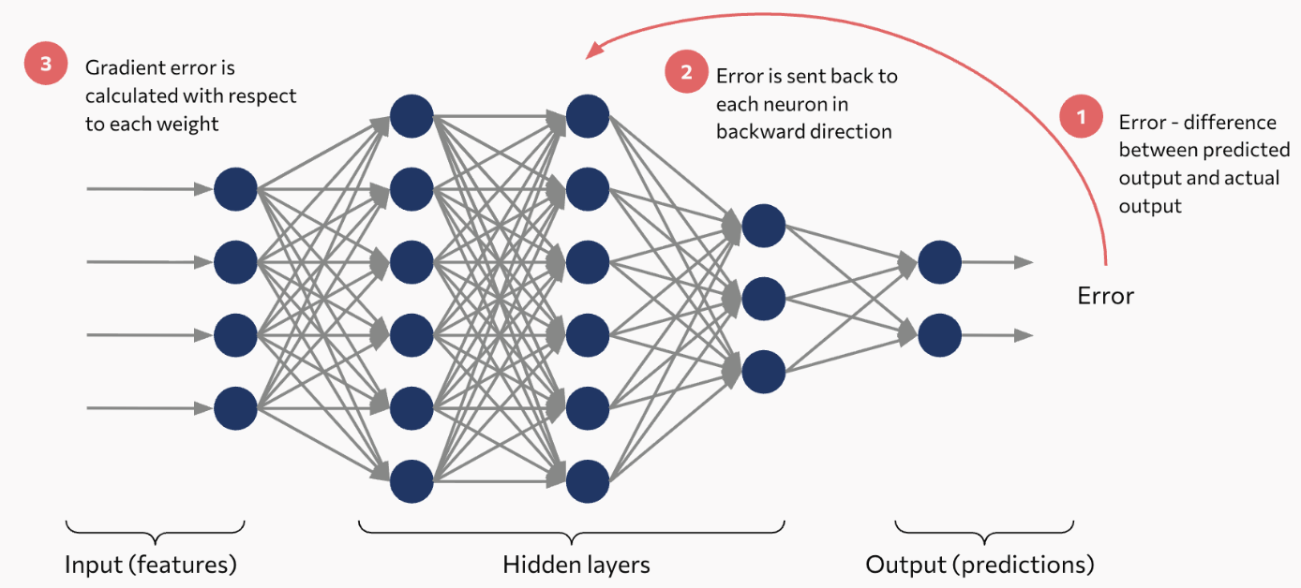
Figure - Backpropagation
- Step 1: Compute the loss Compare the prediction to the ground truth. The difference, quantified as the loss or error, measures prediction accuracy. This scalar value serves as the objective function for optimization.
- Step 2: Propagate error gradients backward The error signal propagates backward through the network (opposite to forward propagation), layer by layer. At each layer, the algorithm calculates how much each weight contributed to the total error through the chain rule of calculus.
- Step 3: Compute weight gradients For each weight, compute its gradient—the partial derivative of the loss with respect to that weight. This gradient indicates the direction and magnitude of change needed to reduce error.
Key insight: Backpropagation leverages the chain rule from calculus to efficiently compute gradients for all parameters simultaneously. It determines the direction of steepest descent in the loss landscape without requiring exhaustive search.
1.3 Gradient Descent: The Update Strategy
Backpropagation identifies which direction to move. Gradient descent determines how much to move.
The update rule: $w_{\text{new}}=w_{\text{old}}-α\frac{∂J}{∂w}$
Where:
- $w$: Network parameter (weight or bias)
- $α$: Learning rate (step size hyperparameter)
- $\frac{∂J}{∂w}$: Gradient of loss with respect to the parameter
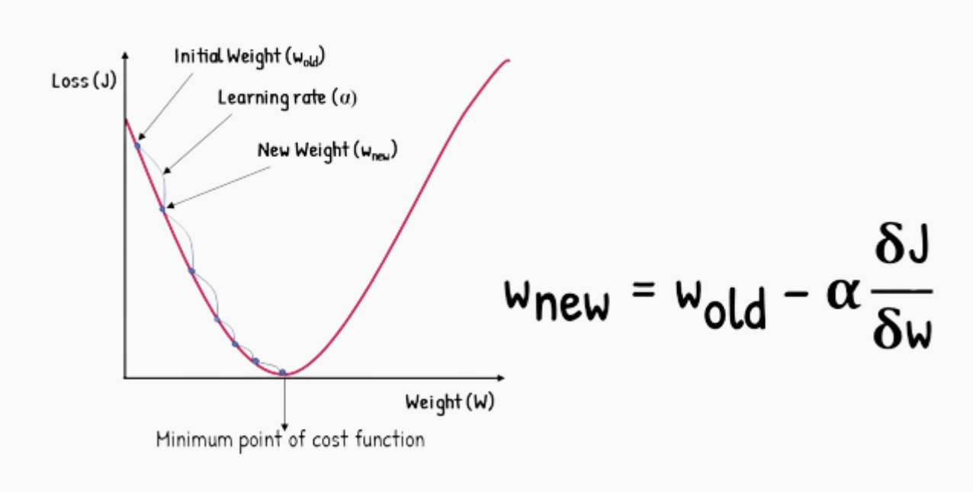
Figure - Gradient Descent Optimization
Starting from an initial weight (w_old), the algorithm computes the gradient (∂J/∂w) at that point and takes a step proportional to the learning rate (α) in the direction of steepest descent, arriving at a new weight (w_new) closer to the loss function minimum.
The training loop:
At each iteration:
- Calculate gradients for all weights (via backpropagation)
- Update each weight by stepping toward lower error
- Repeat thousands of times
Common confusion: Backpropagation and gradient descent serve different roles. Backpropagation computes the gradient of loss with respect to each weight. Gradient descent applies those gradients to update the weights. Think of it this way: backpropagation determines direction, gradient descent determines step size.
1.4 The Learning Rate: Finding the Sweet Spot
The learning rate controls how aggressively your network learns. It's your most important tuning parameter.
Think of it as step size when descending a mountain:
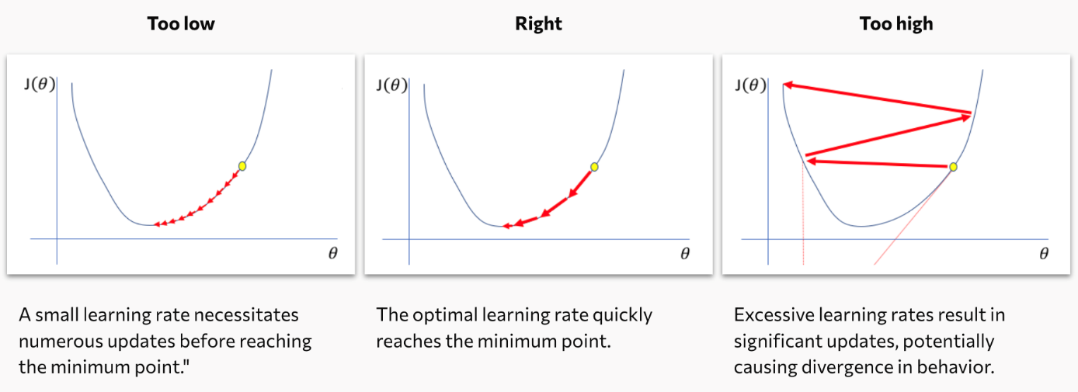
Figure - Learning Rate Selection
Observable behavior:
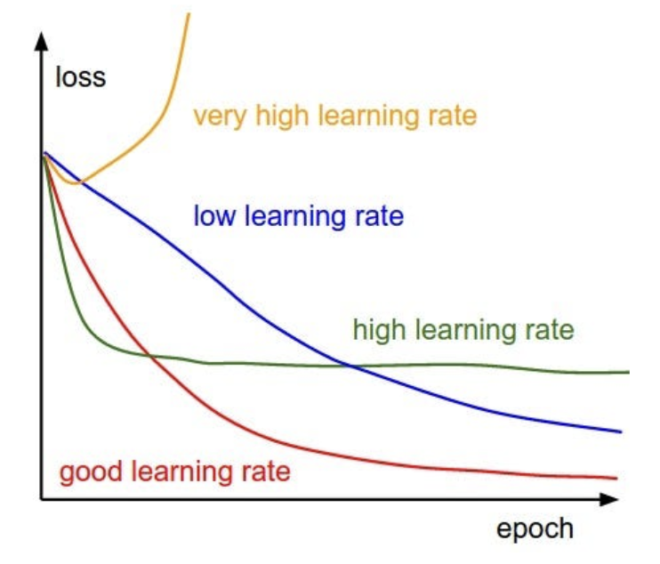
Figure - Training Dynamics Across Learning Rate Regimes
Unstable loss curves with large fluctuations typically indicate excessive learning rate. Reducing by one order of magnitude often stabilizes training. This is a primary diagnostic when troubleshooting training instability.
Tip: Start with 0.001 or 0.01, then tune based on observed loss behavior.
2. Optimization Algorithms
2.1 Beyond Vanilla Gradient Descent
Standard gradient descent applies uniform learning rates to all parameters throughout training. This is an inefficient approach given the heterogeneous nature of neural network loss landscapes.
Modern optimizers employ adaptive strategies:
- Per-parameter learning rate adjustment
- Momentum accumulation for consistent gradient directions
- Adaptive damping in volatile regions
- Efficient navigation of complex loss surfaces
These represent the evolution from fixed-schedule optimization to adaptive, parameter-specific learning.
2.2 Common Optimization Algorithms
- SGD (Stochastic Gradient Descent): Approximates gradients using random mini-batches rather than the full dataset. Reduces computational cost while introducing beneficial noise for escaping shallow local minima.
- Adam (Adaptive Moment Estimation): Industry standard optimizer. Maintains exponential moving averages of both gradients (first moment) and squared gradients (second moment) to adaptively scale per-parameter learning rates. Robust across diverse problem domains.
- RMSProp (Root Mean Square Propagation): Adapts learning rates using moving average of squared gradients. Particularly effective for recurrent architectures and non-stationary objectives.
2.3 Practical Implementation
Now let's see how to configure these optimizers in your code.
model.compile(
loss='binary_crossentropy',
optimizer='adam', # alternatives: 'sgd', 'rmsprop'
metrics=['accuracy']
)
Breaking it down:
- loss='binary_crossentropy': Defines how to measure prediction error (suitable for binary classification)
- optimizer='adam': Specifies the optimization algorithm (Adam adapts learning rates automatically)
- metrics=['accuracy']: Tracks classification accuracy during training and validation
Practical recommendation: Default to Adam with standard hyperparameters for new projects. Its robustness and minimal tuning requirements make it suitable for most applications. Consider alternatives when replicating published work, addressing specific optimization challenges, or when Adam demonstrates suboptimal performance.
3. Regularization Strategies
3.1 Understanding Overfitting
Overfitting occurs when models learn training-specific patterns, including noise and artifacts, at the expense of generalization. The model essentially memorizes training examples rather than extracting underlying patterns.
Model fit spectrum:
- Underfitting: Insufficient model capacity. Fails to capture data patterns. Poor performance on both training and validation sets.
- Optimal fit: Appropriate capacity and training. Captures generalizable patterns. Strong performance on training data that transfers to validation data.
- Overfitting: Excessive capacity or training duration. Memorizes training-specific details. Excellent training performance, degraded validation performance.
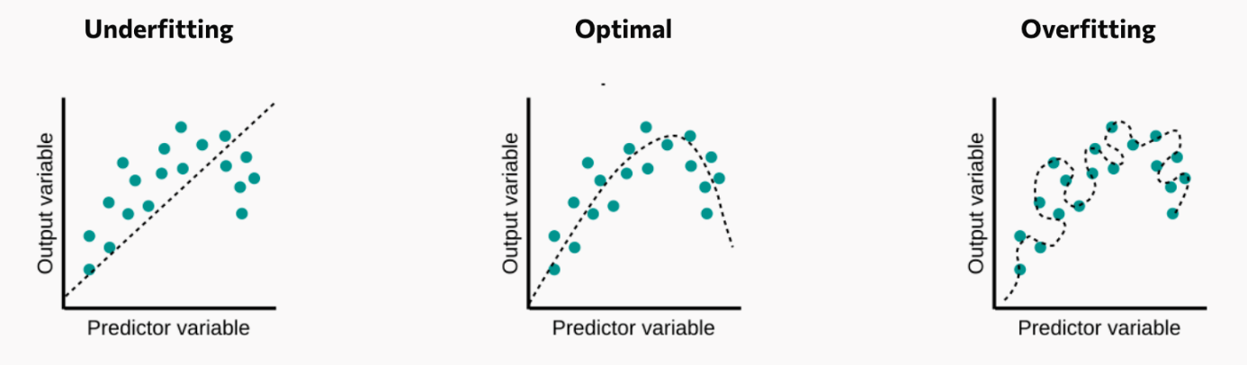
Figure - Underfitting vs. Overfitting
Diagnostic signature: Training loss continues decreasing while validation loss increases—indicating learning of non-generalizable patterns.
3.2 Regularization Methods
Regularization constrains model complexity to promote generalization.
- L2 Regularization (Weight Decay)
It adds penalty term proportional to squared weight magnitudes to the loss function. Discourages large weights, promoting distributed learning across features.
from tensorflow.keras.regularizers import l2
model.add(Dense(128, activation='relu',
kernel_regularizer=l2(0.01)))
It encourages balanced parameter magnitudes rather than extreme values.
- Early Stopping
It monitors validation performance during training. Terminates training when validation metrics plateau or degrade, even if training metrics continue improving. Captures the model at optimal generalization.
- Dropout:
It randomly deactivates neurons during training (typical rates: 0.2-0.5). Prevents co-adaptation by ensuring the network develops distributed, robust representations.
model.add(Dense(128, activation='relu'))
model.add(Dropout(0.3)) # 30% dropout rate
It prevents over-reliance on specific neuron combinations, encouraging redundant encoding of features.
- Batch Normalization
Normalizes layer inputs to zero mean and unit variance. Primary purpose is training stabilization and acceleration, with secondary regularization effect from mini-batch statistics variance.
Implementation strategy: Begin with dropout (0.2-0.5) and early stopping. If substantial training-validation performance gap persists, incorporate L2 regularization. Use validation metrics to guide regularization strength.
Validation data: When training a model, it is a best practice to use validation data for training decisions (when to stop, hyperparameter tuning) and reserve test data exclusively for final evaluation. Tuning based on test performance leads to overfitting on the test set.
Key Takeaways
- Neural networks learn through backpropagation (gradient computation via chain rule) combined with gradient descent (parameter updates along negative gradient direction)
- Learning rate critically affects convergence: excessive values cause instability, insufficient values slow convergence—typical initialization: 0.001-0.01
- Adaptive optimizers like Adam provide per-parameter learning rate adjustment and momentum, offering robust performance across diverse problems—recommended as default choice
- Overfitting manifests when training loss decreases while validation loss increases, indicating memorization rather than pattern learning
- Regularization techniques (dropout, L2 penalty, early stopping) constrain model complexity to improve generalization

